# TK1143 Program Design QUEUE

Section A:

1. Write a java statement to declare and create:
   1. An object variable timeQueue that represent a data of arrival time of a passenger.

Queue <String> timeQueue = new Queue <String> ( ) ;

Queu

* 1. An object variable author with data type BOOK class.

Queue <String> author = new Queue <String> ( ) ;

1. Complete the following table with the description of each method in Queue.

|  |  |
| --- | --- |
| Method | Description |
| isEmpty( ) | To check if the queue is empty |
| enqueue( ) | To add item into the queue |
| dequeue( ) | To remove the front item from the queue |
| peek() | To retrieve the front item without removing it |
| size( ) | To get the number of items in the queue |

1. Complete the following table that shows a series of stack operations and their effects on an initially empty queue Q of character.

|  |  |  |
| --- | --- | --- |
| **Method** | **Return Value** | **First < Q < Last** |
| enqueue(p) | - | [p] |
| enqueue(r) | - | [p, r] |
| size( ) | 2 | [p, r] |
| first ( ) | p | [p, r] |
| enqueue (o) | - | [p, r, o] |
| isEmpty ( ) | false | [p, r, o] |
| dequeue ( ) | P | [r, o] |
| dequeue ( ) | r | [o] |
| size ( ) | 1 | [o] |
| dequeue ( ) | o | [ ] |
| isEmpty ( ) | true | [ ] |
| enqueue (g) | - | [g] |
| enqueue (h) | - | [g, h] |
| first ( ) | g | [g, h] |
| dequeue ( ) | g | [h] |
| size ( ) | 1 | [h] |
| first ( ) | h | [h] |

1. Refer to the given program. Draw a diagram to represent the following queue operations, step-by-step as the program executes. Show the output, if any.

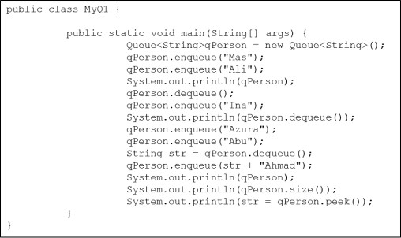

Ina Azura

Ali Ina

Ali

Mas Ali

Mas

Azura Abu InaAhmad

Ina Azura Abu

**Output:**

[Mas, Ali]

Ali

[ Azura, Abu, InaAhmad]

3

Azura

# Section B:

1. What is the output of the following program? Draw the content of vChar.

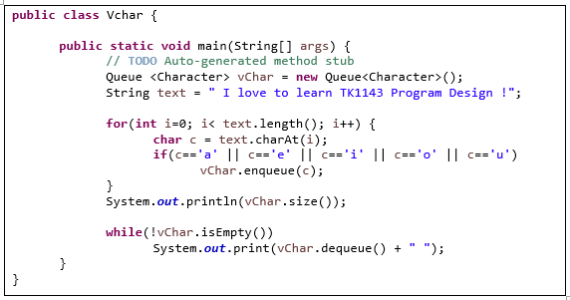

**Output :**

40

I love to learn TK1143 Program Design ! (vertical form)

1. Complete the following program, trace and give the output.

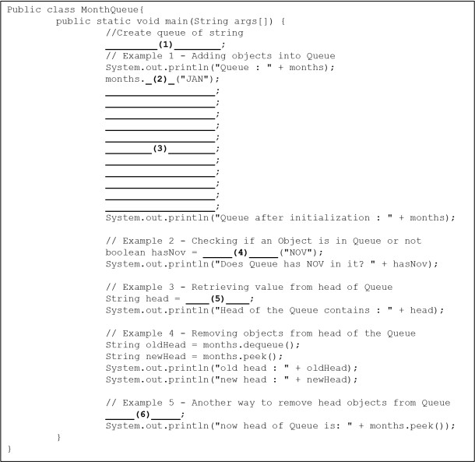

**Output :**

Queue: []

Queue after initialization: [JAN, FEB, MAR, APR, MAY, JUN, JUL, AUG, SEP, OCT, NOV, DEC]

Does Queue has NOV in it ?true

Head of the Queue contains: JAN

Old head: JAN

New head: FEB

now head of Queue is: MAR

1. Queue <String> months = new Queue <String> ( ) ;
2. enqueue
3. months.enqueue(“FEB”) ;

months.enqueue(“MAR”) ;

months.enqueue(“APR”) ;

months.enqueue(“MAY”) ;

months.enqueue(“JUN”) ;

months.enqueue(“JUL”) ;

months.enqueue(“AUG”) ;

months.enqueue(“SEP”) ;

months.enqueue(“OCT”) ;

months.enqueue(“NOV”) ;

months.enqueue(“DEC”) ;

1. months.contains
2. months.peek ( ) ;
3. months.poll ( ) ;
4. What is the output of the following program?

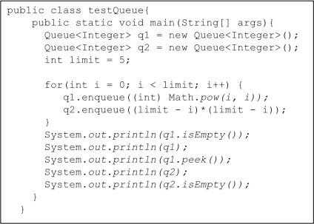

**Output :**

false

[1, 1, 4, 27, 256]

1

[25, 16, 9, 4, 1]

false

1. Trace the given program and give the output.

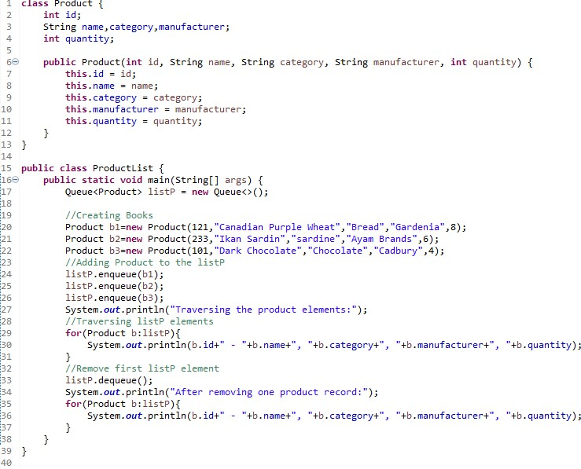

**Output :**

Traversing the product elements:

121 - Canadian Purple Wheat - Bread - Gardenia - 8

233 - Ikan Sardin - sardine - Ayam Brands - 6

101 - Dark Chocolate - Chocolate - Cadbury - 4

After removing one product record:

233 - Ikan Sardin - sardine - Ayam Brands - 6

101 - Dark Chocolate - Chocolate - Cadbury - 4

1. Complete the following program as input and output given.

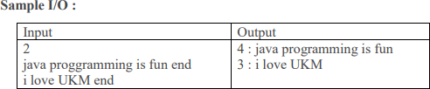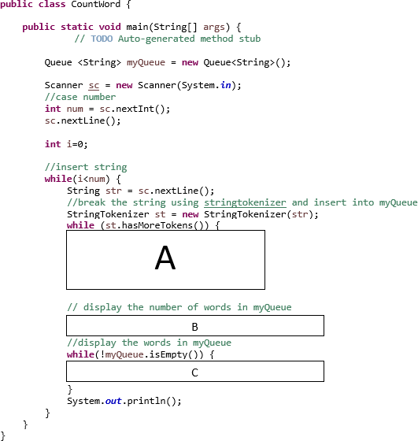

# Section C:

There are four (4) questions given in this section. Your task is to write the program to implement data structure Stack for each case.

|  |  |
| --- | --- |
| **ODD EVEN NUMBER** | |
| Input | Standard Input |
| Output | Standard Output |
| Programming Elements | Loop |
| Data Structure | Queue |

## Problem Description

Even Numbers are integers that are exactly divisible by 2, whereas an odd number cannot be exactly divided by 2. Example of even numbers are 2,4,6,8 and odd numbers are 1, 3, 5, 7, 9.

## Input

The first line input contains an integer, which determines the number of test cases. Each of following lines represent sequence of integers that ends with 0.

2

34 1 8 5 22 0

10 7 16 -2 0

## Output

For each test case, the output will present the size of oddQueue and evenQueue following with the integers of odd and even numbers.

oddQueue 2: 1 5

evenQueue 3: 34 8 22

oddQueue 1: 7

evenQueue 3: 10 16 -2

Your task is to write a program that will read the input and identify whether it is an even number or odd number.

## Self-Study

* 1. Explain the implementation of Queue in this case study.

|  |  |
| --- | --- |
| **PALINDROME** | |
| Input | Standard Input |
| Output | Standard Output |
| Programming Elements | Loop |
| Data Structure | Stack & Queue |

## Problem Description

Palindrome is a sequence of characters, a word, phrase, number or sequence of words, which reads the same backward as forward. Example of palindrome words are katak, civic and anna.

## Input

The first line input contains an integer, which determines the number of test cases. Each of following lines represent words.

3

racecar java madam

## Output

For each test case, the output contains respond either ‘It is a Palindrome’ or ‘Not a palindrome’. It is a Palindrome

Not a palindrome It is a Palindrome

Your task is to write a program that will read the word and identify whether it is a palindrome or not. You must use stack and queue in your program.

## Self Study

1. Explain the implementation of Stack and Queue in this case study.

|  |  |
| --- | --- |
| **ABC WASH MACHINE** | |
| Input | Randomly generated |
| Output | Standard Output |
| Programming Elements | Selection, Looping |
| Data Structure | Queue |
| Additional Function | class Clock, rand() |

## Problem Description

ABC Wash Machine provides a self-wash car for its customer. The customer must queue up in order to get the service. The customer will immediately be served if the queue is empty. If the machine is free, then it will serve the front customer in the queue. The machine takes 5 minutes to complete one service. The machine operation starts at 8.00 am and ends at 8.30 am. However, it will continue serve customer who arrive before or by 8.30 am.

The owner of the ABC Wash Machine would like to know some statistical information so that he can improve the machine in the future. The information are:

* Number of customer that arrives by 8.30 am.
* Longest customer waiting time.
* Average customer waiting time.

•

Assume that all customers are an ethical person and determined to get the service, also the machine is ideal. Input for customer arrival times will randomly generated by rand() function. Assume that the next customer is likely to arrive within 9 minutes after the current customer.

Your task is to modify the given program that will print out the report information as below.

## Input

Randomly generated.

## Sample Output

*<List of car arrival time>*

Car arrival : <car arrival time> < <ABC wash machine end time>

*< list of car waiting time information>*

Customer: <Start_served> waitQueue: <Car_arrival_time> washEnd: <Servise_has_ended> carwait: <Waiting_time_per_customer> maxDur: < Longest_waiting_time>

Totalwait: <Sum_of_waiting_time> Totalwork: <Sum_of_machine_works>

REPORT

Number of customer that arrives by 8.30 am: <Number_ customer _arrives_by 8.30> Longest waiting time: < Longest_waiting_time>

Average waiting time: < Average_waiting_time>

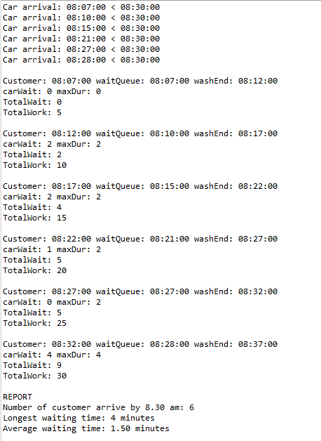

## Solution

The algorithm for ABC Wash Machine simulation:

*Set the operation time.*

*Generate all car arrivals, and push them onto arrival queue.*

*Set the initial state for the wash machine (status, startWash, endWash) Set current event.*

While there is still an event

*If car arrival event occurs:*

*Push car onto waiting queue. If machine finish washing*

*Update machine state.*

*If machine available and there is a car waiting:*

*Front car in waiting queue will be washed.*

*Remove this car from waiting queue.*

*Update the machine state and statistical information. If machine available and there is no car waiting:*

*Update endWash to beyond operation time.*

*Jump to the next earliest event that is either car arrival or machine finish washing.*

Produce report

# Basic Structure:

int main(){

Clock carArrival;

Queue <Clock> waitQueue; Queue <Clock> arrivalQueue;

enum status {free, busy} machineWash;

//observation data

Clock totalWaitTime, maxWaitTime; Clock totalServiceTime;

Clock startTime, endTime; Clock washEnd, washStart;

Clock i;

int nextArrival;

for (i=startTime;(i.lessThan(endTime)||(!waitQueue.empty())||(!arrivalQueue.empty()));)

{

}



return 0;

}

Full structure of the worked-example program: ABC Wash Machine Simulation

|  |  |
| --- | --- |
| 1  2  3  4  5  6  7  8  9  10  11  12  13  14  15  16  17  18  19  20  21  22  23  24  25  26  27  28  29  30  31  32  33  34  35  36  37  38  39  40  41  42  43  44  45  46  47  48  49  50  51  52  53  54  55  56  57  58  59  60  61  62  63  64  65  66  67  68  69  70  71  72  73  74 | **import** java.util.*;  **public class** ABCWashMachine {  **public enum** status { ***free***, ***busy***}  **static int** *maxDur*=0; **static int** *numCar*=0; **static int** *totalWait*=0; **static int** *totalWork*=0;  **public static void** main(String[] args) { Clock carArrival;  Queue <Clock> waitQueue= **new** Queue <>(); Queue <Clock> arrivalQueue = **new** Queue<>();  //enum status {free, busy} machineWash; status machineWash;  //observation data  Clock totalWaitTime= **new** Clock(); Clock maxWaitTime = **new** Clock(); Clock totalServiceTime = **new** Clock(); Clock startTime= **new** Clock();  Clock endTime= **new** Clock(); Clock washEnd = **new** Clock(); Clock washStart = **new** Clock();  Clock i;  **int** nextArrival=0;  Random rand = **new** Random();  startTime.setTime(8,0,0); endTime.setTime(8,30,0); // can change to 12 pm  **for** (i=startTime.getCopy();i.lessThan(endTime); ){  nextArrival = rand.nextInt(10); //nextArrival in the range 0 to 9 i.addTimeMinute(nextArrival);  **if**(i.lessThan(endTime)) {  arrivalQueue.enqueue(i.getCopy()); System.***out***.println("car arrival: " + i.toString() + " < " +  endTime.toString());  }  }  //start the simulation machineWash=status.***free***; **if** (!arrivalQueue.isEmpty()) {  startTime=arrivalQueue.peek(); washEnd=startTime.getCopy(); washEnd.addTimeMinute(5);  } **else**  startTime=endTime.getCopy();  Clock del;  **for**  (i=startTime;(i.lessThan(endTime)||(!waitQueue.isEmpty())||(!arrivalQueue.isEmpty()));)  {  **if** (!arrivalQueue.isEmpty())  **if** (i.equalTime(arrivalQueue.peek())) { waitQueue.enqueue(i.getCopy()); del=arrivalQueue.dequeue();  }  **if** ((machineWash==status.***busy***) && (i.equalTime(washEnd))) { washEnd.setTime(14,0,0); machineWash=status.***free***;  }  **if** ((machineWash==status.***free***) && !(waitQueue.isEmpty())) { washStart=i.getCopy();  washEnd=i.getCopy(); washEnd.addTimeMinute(5); *doAnalysis*(i,waitQueue.peek(),washEnd); // call doAnalysis method del=waitQueue.dequeue();  machineWash=status.***busy***;  } |

|  |  |
| --- | --- |
| 75  76  77  78  79  80  81  82  83  84  85  86  87  88  89  90  91  92  93  94  95  96  97  98  99  100  101  102  103  104  105  106  107  108  109  110  111  112  113  114 | **if** ((machineWash==status.***free***) && (waitQueue.isEmpty())) washEnd.setTime(14,0,0);  //jump to next event.  **if** (!arrivalQueue.isEmpty())  **if** (washEnd.lessThan(arrivalQueue.peek())) { i=washEnd.getCopy();  }  **else** {  i=arrivalQueue.peek().getCopy();  }  **else** {  i=washEnd.getCopy();  }  }  //report System.***out***.print("\nREPORT\n");  System.***out***.print("Number of customer arrive by 8.30 am: " + *numCar* + "\n"); System.***out***.print("Longest waiting time: " + *maxDur* + " minutes\n"); System.***out***.print(String.*format*("Average waiting time: %.2f minutes",  *totalWait*/(**float**)*numCar*));  }  **public static void** doAnalysis(Clock waitStop, Clock start, Clock washStop) {  **int** carWait,machineWork;  carWait=start.durationSec(waitStop.getCopy()); machineWork=waitStop.durationSec(washStop.getCopy()); *numCar*++;  *totalWait*+= carWait; *totalWork*+=machineWork; **if** (*maxDur*<carWait)  *maxDur*=carWait;  }  } |

## Self-activity

1. What is the statistical information needed in this problem?
2. Let say, the wash machine operation hours is from 8.00am to 9.00am and the machine takes 10 minutes to complete one service. The car arrival times are as follows:

i. 8.05am, 8.09am, 8.12am, 8.25am, and 8.55am.

1. Calculate the statistical information in this case.
2. Determine the simulation characteristic of the ABC Wash Machine.

## Tutorial Activity

1. How the program get the input of customer’s arrival?
2. List the variables of type Clock.
3. What is the data type used to determine the average waiting time and number of customer. Why?
4. List out the standard function and user defined function used in the given program.
5. Identify main and supportive identifiers in the program
6. Which line in the program shows the following?
   * Generate all car arrivals, and push them onto arrival queue.
   * Set the initial state for the wash machine
   * Jump to the next earliest event that is either car arrival or machine finish washing.
   * Update the statistical information.
7. If we were to change the machine working hours from 8am -9am, which line of code need to be change?

## Hands-on Activity

Implement the worked-example of ABC Wash Machine program. Try to understand the output printed by the program.

|  |  |
| --- | --- |
| **DEF WASH MACHINE** | |
| Input | Randomly generated |
| Output | Standard Output |
| Programming Elements | Selection, Looping |
| Data Structure | Queue |
| Additional Function | class Clock, rand() |

## Problem Description

The DEF Wash Machine problem will use the same problem description as the worked- example of ABC Wash Machine with regard the DEF Wash Machine provides two types of services:

Type 1: normal wash (takes 6 minutes for every service) Type 2: wash and polish (takes 10 minutes for every service).

The owner of the DEF Wash Machine would like to know the statistical information as below:

* Total customers: <total_customer>
* Number of customers for service of type 1: <Number_ customer _type_1>
* Number of customers for service of type 2: <Number_ customer _type_2>
* Longest customer waiting time: < Longest_waiting_time>
* Average customer waiting time: < Average_waiting_time>

Your task is to modify the worked-example of ABC Wash Machine and print out the above statistical information.

## Input

Input are randomly generated for both - car arrival and services type.

## Sample Output

Total customers:

Number of customers for service of type 1: <Number_ customer _type_1> Number of customers for service of type 2: <Number_ customer _type_2> Longest customer waiting time: < Longest_waiting_time>

Average customer waiting time: < Average_waiting_time>

## Tips

1. Queue in DEF Wash Machine problem holds two information: arrival time and service type. Therefore, we would like to suggest you to use class Customer as follows:

|  |  |
| --- | --- |
| 1  2  3  4  5  6  7  8  9  10  11  12  13  14  15  16  17  18  19  20  21  22  23  24  25  26  27  28  29  30  31  32  33  34  35  36  37  38  39  40  41  42  43  44  45  46  47  48  49 | **public class** Customer {  Clock time = **new** Clock ();  **int** serviceType;  **public** Customer (Clock tm, **int** sType)  {  time.setTime(tm.getHours(),tm.getMinutes(),tm.getSeconds()); serviceType = sType;  }  **public** Customer()  {  time.setTime(0,0,0); serviceType =0;  }  **public int** getSeviceType()  {  **int** temp; temp=**this**.serviceType; **return** temp;  }  **public int** setSeviceType()  {  **int** temp; temp=**this**.serviceType; **return** temp;  }  **public** Customer CopyCustomer()  {  Customer temp = **new** Customer(); temp.time = time.getCopy(); temp.serviceType= getSeviceType(); temp.toString();  **return** temp;  }  **public** String toString()  {  String str;  str = **this**.time.toString();  str = str + " (" + serviceType + ") ";  **return** str;  }  } |

1. Be careful with your variable WashEnd. (Why?)
2. Manipulation of a queue, which hold single information is simple. However, queue which hold complex information such as class Customer is not easy to handle. Hence, we give you code example on how to manipulate this type of queue.

Clock i = **new** Clock(); Customer car = **new** Customer(); **int** nextArrival, carService;

Queue <Customer> myQueue = **new** Queue<>();

nextArrival = rand.nextInt(10); // nextArrival in the range 0 to 9 i.addTimeMinute(nextArrival);

car.time = i.getCopy(); car.serviceType = 2; myQueue.enqueue(car.CopyCustomer()); **if**(arrivalQueue.peek().serviceType==2)

System.out.print("service type is 2- Wash Only" );

# DEF Wash Machine simulation algorithm:

*Set the operation time.*

*Generate all car arrivals and its service type, and push them onto arrival queue. Set the initial state for the wash machine (status, startWash, endWash)*

*Set current event.*

*While there is still an event*

*If car arrival event occurs:*

*Push car onto waiting queue.*

*If machine finish washing Update machine state.*

*If machine available and there is a car waiting: Front car in waiting queue will be washed. Remove this car from waiting queue.*

*Update the machine state and statistical information.*

*If machine available and there is no car waiting: Update endWash to beyond operation time.*

*Jump to the next earliest event that is either car arrival or machine finish washing.*

*Produce report.*

## Tutorial Activity

1. Determine the simulation characteristics of the DEF Wash Machine simulation.
2. What is the difference between ABC Wash Machine algorithm and DEF Wash machine algorithm?
3. What is the different between queue in ABC Wash Machine and queue in DEF Wash machine?
4. What are the modifications needed from the ABC Wash Machine code/program?